
Company
Logotype

Cone Beam Computed Tomography- Report



Porur Dental X-rays & CBCT

Patient Name : Master. Gyan Raj | Date of Report : 03.06.2024
Age/ Gender : 14 years/ Male | Region of Interest : CBCT Anterior Maxilla
Referring doctor: PEDOPLANET | Indication : Sinus tract irt 21, 22
Clinical Notes: Nil
PATIENT INFORMATION

CBCT Anterior Maxilla provided
CBCT – IMAGE DETAILS

RADIOGRAPHIC INTERPRETATION

- In relation to the periapical aspect of 21, 22 presence of a diffuse periapical hypodense area measuring 11.04 x 15.99 x 12.33 mm in dimension surrounded by a sclerotic margin is evident.
- Along the periapical aspect of 21, presence of a small hyperdense area in the apical third extending into the hypodense area is evident.
- The hypodense area appears to cause extreme thinning of the labial and palatal cortical plate and lies in close proximity to the nasal floor and incisive canal.
- The hypodense area appears to extend into the lateral aspect of 22, almost involving the radicular portion of 23.
- In relation to the labial aspect- along the interdental region of 21, 22, presence of a thin hypodense discontinuity evident, that extends from the labial aspect and enters the hypodense area.
- Presence of a similar area with mild hypodensity and a small region of hyperdensity in relation to the periapical aspect of 11, 12 is evident.

RADIOGRAPHIC IMPRESSION

- Differential Diagnosis (based on the visible radiological features): Periapical pathology in relation to 21, 22.


Kindly correlate with clinical and histopathological features

IMAGES FOR REFERENCE

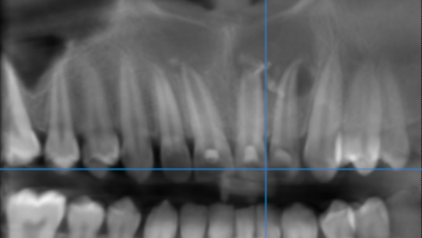

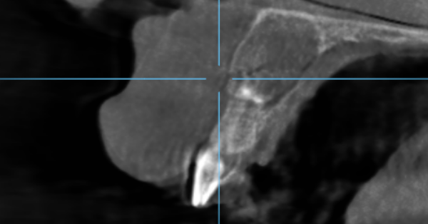
SAGITTAL IMAGES FOR REFERENCE
CROSS SECTIONAL IMAGES FOR REFERENCE

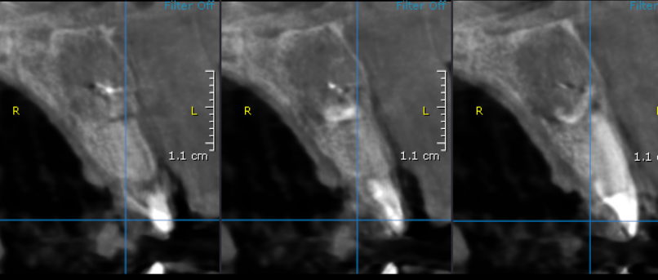

3-DIMENSIONAL VIEW

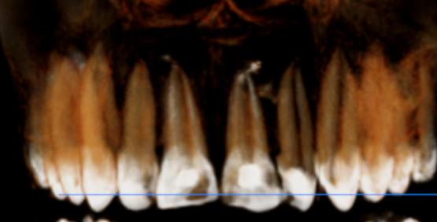

**** End of report ****

